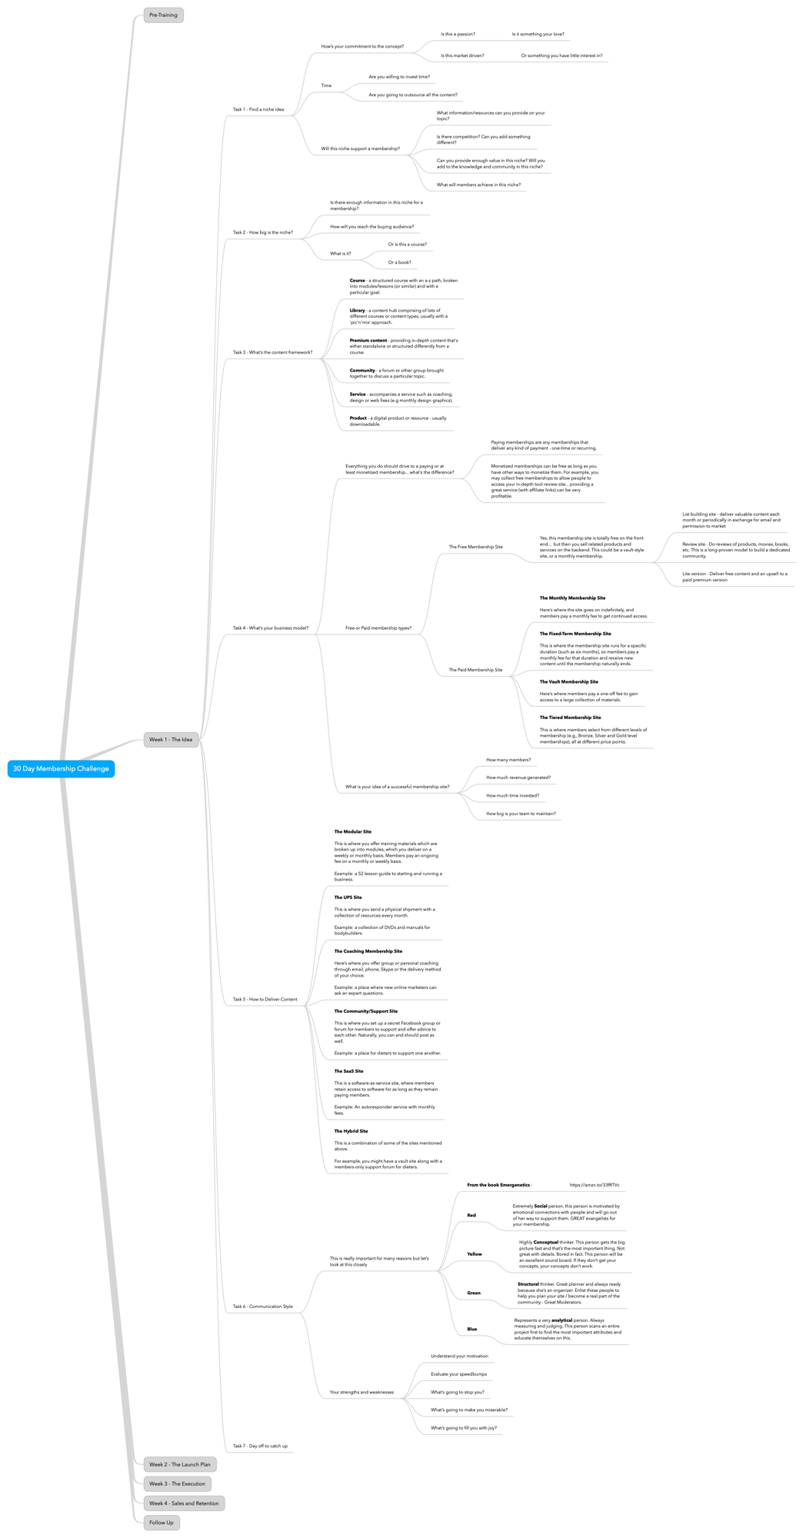

30 Day Membership Challenge

- Pre-Training
- Week 1 - The Idea
  - Task 1 - Find a niche idea
    - How’s your commitment to the concept?
      - Is this a passion?
        - Is it something your love?
      - Is this market driven?
        - Or something you have little interest in?
    - Time
      - Are you willing to invest time?
      - Are you going to outsource all the content?
    - Will this niche support a membership?
      - What information/resources can you provide on your topic?
      - Is there competition? Can you add something different?
      - Can you provide enough value in this niche? Will you add to the knowledge and community in this niche?
      - What will members achieve in this niche?
  - Task 2 - How big is the niche?
    - Is there enough information in this niche for a membership?
    - How will you reach the buying audience?
    - What is it?
      - Or is this a course?
      - Or a book?
  - Task 3 - What’s the content framework?
    - Course - a structured course with an a-z path, broken into modules/lessons (or similar) and with a particular goal.
    - Library - a content hub comprising of lots of different courses or content types, usually with a 'pic'n'mix' approach.
    - Premium content - providing in-depth content that's either standalone or structured differently from a course.
    - Community - a forum or other group brought together to discuss a particular topic.
    - Service - accompanies a service such as coaching, design or web fixes (e.g monthly design graphics).
    - Product - a digital product or resource - usually downloadable.
  - Task 4 - What’s your business model?
    - Everything you do should drive to a paying or at least monetized membership... what’s the difference?
      - Paying memberships are any memberships that deliver any kind of payment - one-time or recurring.
      - Monetized memberships can be free as long as you have other ways to monetize them. For example, you may collect free memberships to allow people to access your in-depth tool review site... providing a great service (with affiliate links) can be very profitable.
    - Free or Paid membership types?
      - The Free Membership Site
        - Yes, this membership site is totally free on the front end… but then you sell related products and services on the backend. This could be a vault-style site, or a monthly membership.
          - List building site - deliver valuable content each month or periodically in exchange for email and permission to market
          - Review site - Do reviews of products, movies, books, etc. This is a long-proven model to build a dedicated community.
          - Lite version - Deliver free content and an upsell to a paid premium version
      - The Paid Membership Site
        - The Monthly Membership Site
Here’s where the site goes on indefinitely, and members pay a monthly fee to get continued access.
        - The Fixed-Term Membership Site
This is where the membership site runs for a specific duration (such as six months), so members pay a monthly fee for that duration and receive new content until the membership naturally ends.
        - The Vault Membership Site
Here’s where members pay a one-off fee to gain access to a large collection of materials.
        - The Tiered Membership Site
This is where members select from different levels of membership (e.g., Bronze, Silver and Gold level memberships), all at different price points.
    - What is your idea of a successful membership site?
      - How many members?
      - How much revenue generated?
      - How much time invested?
      - How big is your team to maintain?
  - Task 5 - How to Deliver Content
    - The Modular Site
This is where you offer training materials which are broken up into modules, which you deliver on a weekly or monthly basis. Members pay an ongoing fee on a monthly or weekly basis.
Example: a 52 lesson guide to starting and running a business.
    - The UPS Site
This is where you send a physical shipment with a collection of resources every month.
Example: a collection of DVDs and manuals for bodybuilders.
    - The Coaching Membership Site
Here’s where you offer group or personal coaching through email, phone, Skype or the delivery method of your choice.
Example: a place where new online marketers can ask an expert questions.
    - The Community/Support Site
This is where you set up a secret Facebook group or forum for members to support and offer advice to each other. Naturally, you can and should post as well.
Example: a place for dieters to support one another.
    - The SaaS Site
This is a software-as-service site, where members retain access to software for as long as they remain paying members.
Example: An autoresponder service with monthly fees.
    - The Hybrid Site
This is a combination of some of the sites mentioned above.
For example, you might have a vault site along with a members-only support forum for dieters.
  - Task 6 - Communication Style
    - This is really important for many reasons but let’s look at this closely
      - From the book Emergenetics -
        - https://amzn.to/33fRTVc
      - Red
        - Extremely Social person, this person is motivated by emotional connections with people and will go out of her way to support them. GREAT evangelists for your membership.
      - Yellow
        - Highly Conceptual thinker. This person gets the big picture fast and that’s the most important thing. Not great with details. Bored in fact. This person will be an excellent sound board. If they don’t get your concepts, your concepts don’t work.
      - Green
        - Structural thinker. Great planner and always ready because she’s an organizer. Enlist these people to help you plan your site / become a real part of the community - Great Moderators.
      - Blue
        - Represents a very analytical person. Always measuring and judging. This person scans an entire project first to find the most important attributes and educate themselves on this.
    - Your strengths and weaknesses
      - Understand your motivation
      - Evaluate your speedbumps
      - What’s going to stop you?
      - What’s going to make you miserable?
      - What’s going to fill you with joy?
  - Task 7 - Day off to catch up
- Week 2 - The Launch Plan
- Week 3 - The Execution
- Week 4 - Sales and Retention
- Follow Up

